Terraform Challenge 10
Challenge 1 : Create an EC2 Instance on AWS Cloud using Terraform
Objective
The objective of this challenge is to provision an Ubuntu EC2 instance on AWS using Terraform Infrastructure as Code (IaC). Terraform automates infrastructure provisioning, enabling consistent, repeatable, and version-controlled deployments without manual intervention.
Prerequisites
- AWS Account
- Terraform installed
- AWS CLI installed
- AWS CLI configured (aws configure)
- VS Code
- Existing AWS Key Pair
- Existing VPC and Subnet
- IAM user with EC2 permissions
- Internet connectivity
Project Structure
Terraform-Challenge/
│
├── main.tf
├── variables.tf
├── outputs.tf

Implementation Steps
Step 1
Create a project folder.
Terraform-Challenge
Step 2
Open the folder in Visual Studio Code.
Step 3
Create the following files.
- main.tf
- variables.tf
- outputs.tf
Step 4
Configure the AWS provider.
Step 5
Define the AWS region.
Step 6
Specify the Ubuntu AMI.
ami-0461b1436c9b3c1a3
Step 7
Specify the EC2 instance type.
t2.micro
Step 8
Specify the existing AWS Key Pair.
docker-key
Step 9
Specify the subnet ID.
Step 10
Create the EC2 resource using Terraform.
Now main.tf
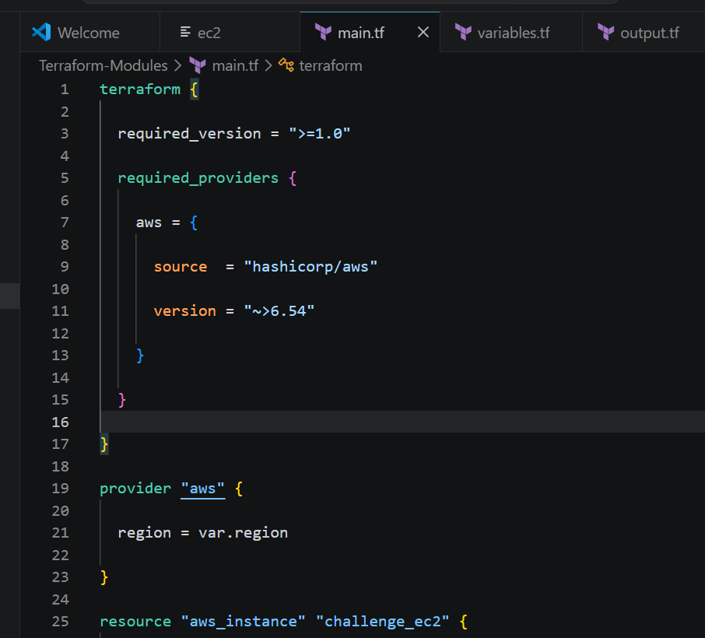
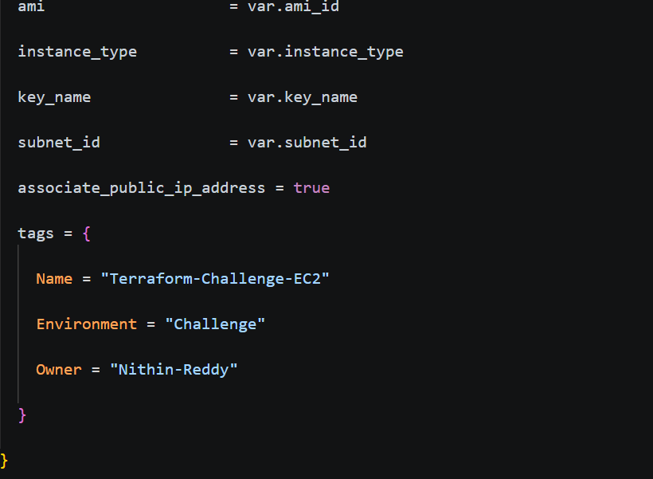
Now variable.tf
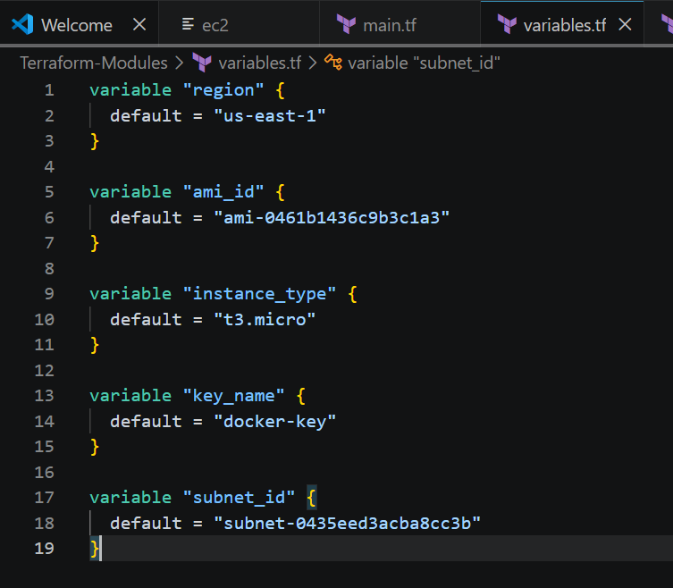

Now output.tf
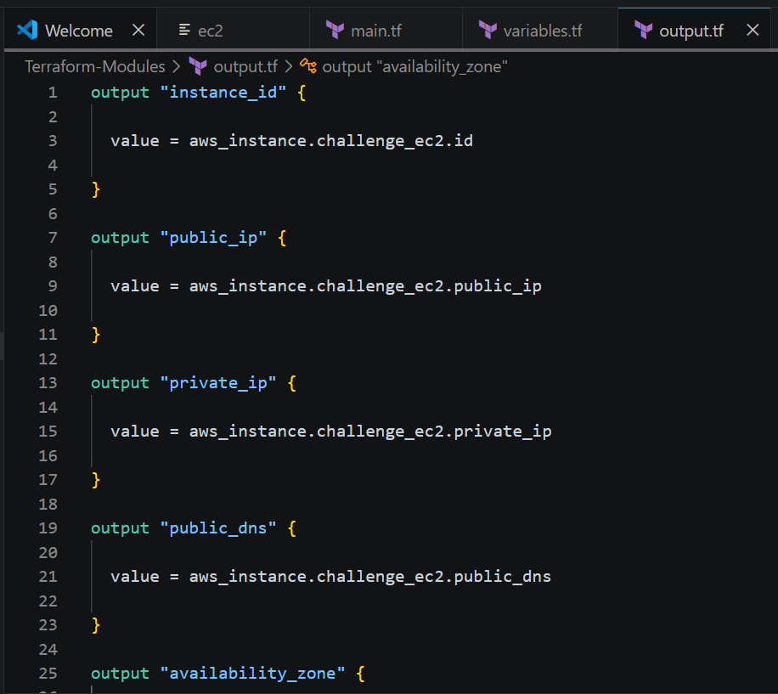
Commands used now
terraform init
terraform fmt
terraform validate
terraform plan
terraform apply
terraform destroy
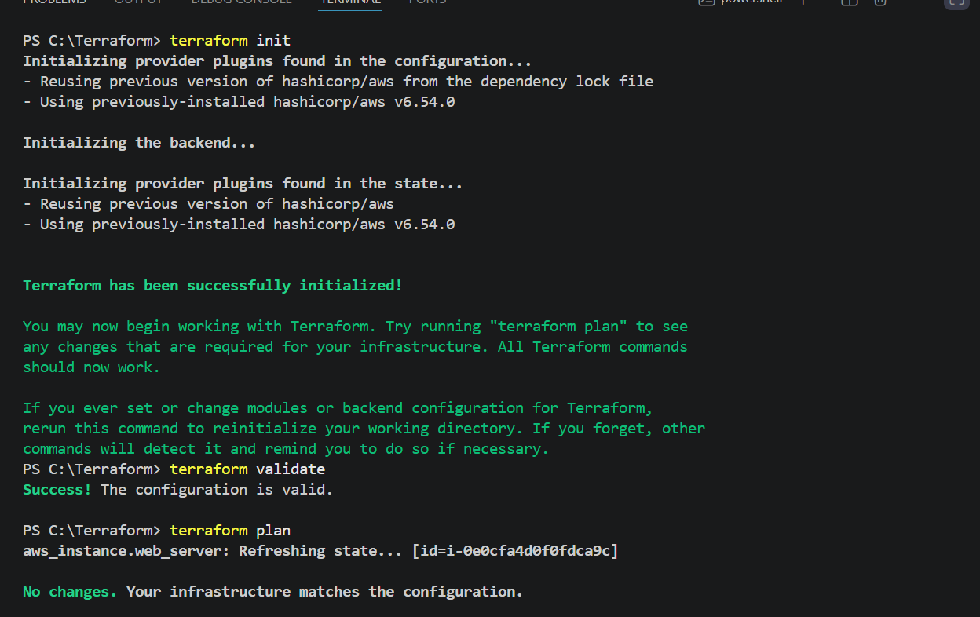
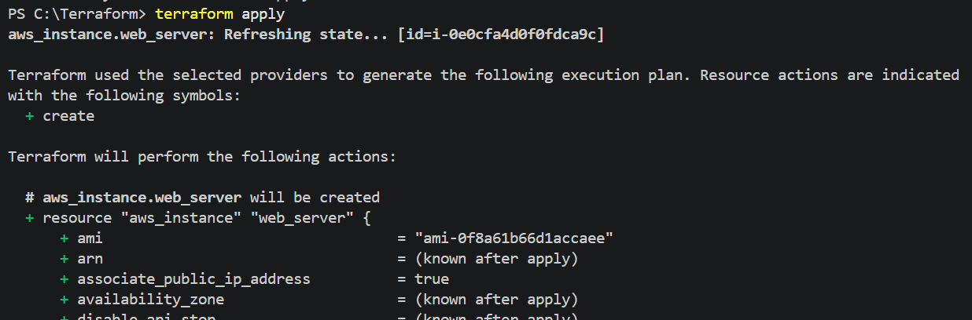
Enter : yes
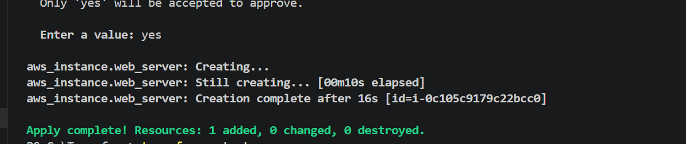
Now challenge ec2 created
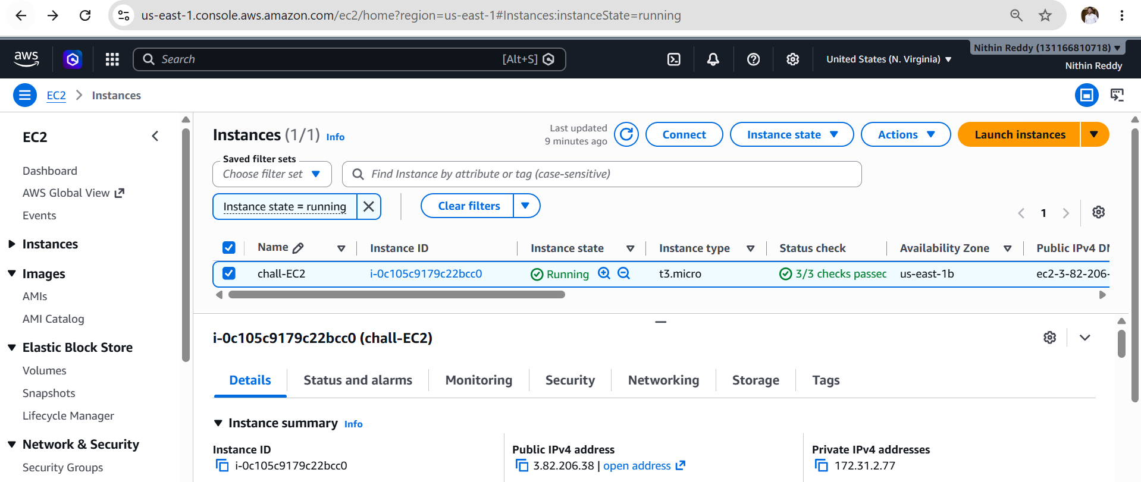
Now destroy
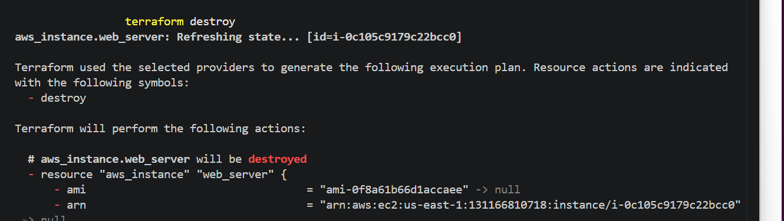

Validation
- Terraform initialized successfully.
- Configuration validated without errors.
- Execution plan generated successfully.
- Ubuntu EC2 instance created successfully.
- EC2 instance is in the Running state.
- Correct AMI and instance type are used.
- Terraform state file created successfully.
- Outputs display the instance details.

Expected Outcome
- Successfully provisioned an Ubuntu EC2 instance using Terraform.
- Infrastructure created using Infrastructure as Code (IaC).
- EC2 instance is ready for the next challenges (web server, Docker Compose, reverse proxy, logging, and log rotation).
- Terraform configuration is reusable, scalable, and version-controlled.

Challenge 2: Install a Web Server on EC2 and Configure it to Listen on Port 8080
Objective
The objective of this challenge is to automatically install and configure a web server on the EC2 instance using Terraform. The web server should start automatically after the instance is launched and listen for HTTP requests on port 8080.
Prerequisites
- Challenge 1 completed successfully.
- Terraform installed.
- AWS CLI configured.
- EC2 instance can access the internet.
- Security Group allows inbound traffic on port 8080.
Project Structure
Terraform-Challenge
│
├── main.tf
├── variables.tf
└── outputs.tf
Implementation Steps
- Complete Challenge 1 by creating the EC2 instance.
- Create a Security Group allowing ports 22 and 8080.
- Attach the Security Group to the EC2 instance.
- Add a user_data script to the EC2 resource.
- Update the package repository.
- Install Nginx automatically.
- Change the Nginx listening port from 80 to 8080.
- Create a custom index.html page.
- Enable the Nginx service.
- Restart the Nginx service.
- Save the Terraform configuration.
- Run terraform init.
- Run terraform fmt.
- Run terraform validate.
- Run terraform plan.
- Run terraform apply.
- Confirm the changes by typing yes.
- Wait for the EC2 instance provisioning to complete.
- Verify the EC2 instance is running in the AWS Console.
- Open http://<Public-IP>:8080 in a browser.
- Confirm that the custom Nginx page is displayed.
- Verify the Nginx service status using systemctl.
- Confirm that port 8080 is listening using ss or netstat
Main.tf
terraform {

required_version = ">= 1.0"

required_providers {
aws = {
source = "hashicorp/aws"
version = "~> 6.54"
}
}
}

provider "aws" {
region = "us-east-1"
}

resource "aws_security_group" "web_sg" {

name = "challenge2-web-sg"
description = "Allow SSH and Port 8080"

vpc_id = "vpc-04e8f564e2d118919"

ingress {
from_port = 22
to_port = 22
protocol = "tcp"
cidr_blocks = ["0.0.0.0/0"]
}

ingress {
from_port = 8080
to_port = 8080
protocol = "tcp"
cidr_blocks = ["0.0.0.0/0"]
}

egress {
from_port = 0
to_port = 0
protocol = "-1"
cidr_blocks = ["0.0.0.0/0"]
}

tags = {
Name = "Challenge2-SG"
}
}

resource "aws_instance" "challenge_ec2" {

ami = "ami-0f8a61b66d1accaee"
instance_type = "t3.micro"

subnet_id = "subnet-0435eed3acba8cc3b"
key_name = "docker-key"

associate_public_ip_address = true

vpc_security_group_ids = [
aws_security_group.web_sg.id
]

user_data = <<-EOF
#!/bin/bash

apt update -y

apt install nginx -y

sed -i 's/listen 80 default_server;/listen 8080 default_server;/g' /etc/nginx/sites-available/default
sed -i 's/listen \\[::\\]:80 default_server;/listen [::]:8080 default_server;/g' /etc/nginx/sites-available/default

echo "<h1>Challenge 2 Completed</h1>" > /var/www/html/index.html
echo "<h2>Nginx Running on Port 8080</h2>" >> /var/www/html/index.html

systemctl enable nginx
systemctl restart nginx

EOF

tags = {
Name = "Challenge2-EC2"
}
}

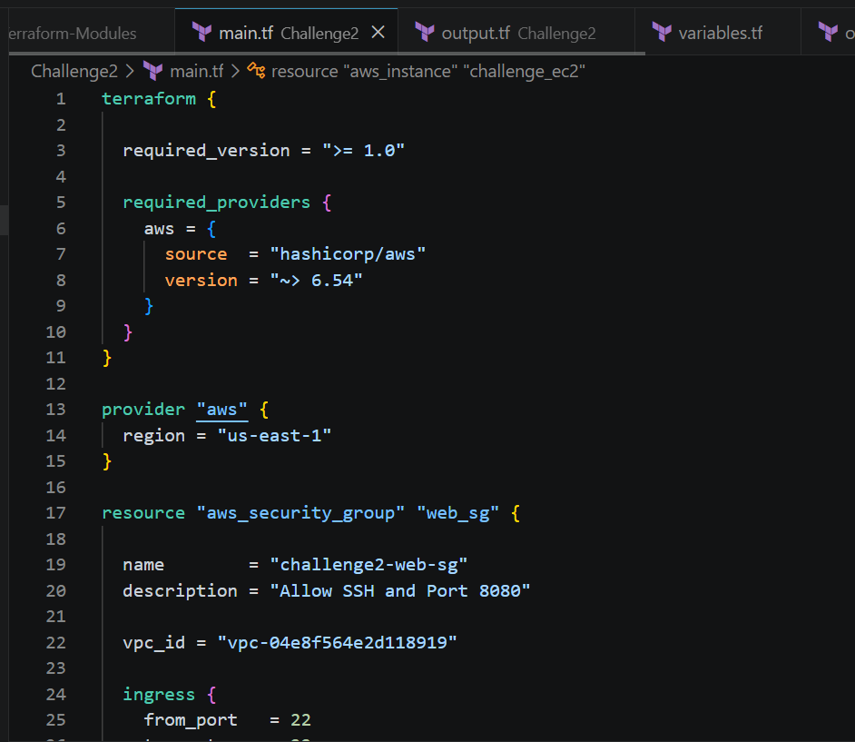
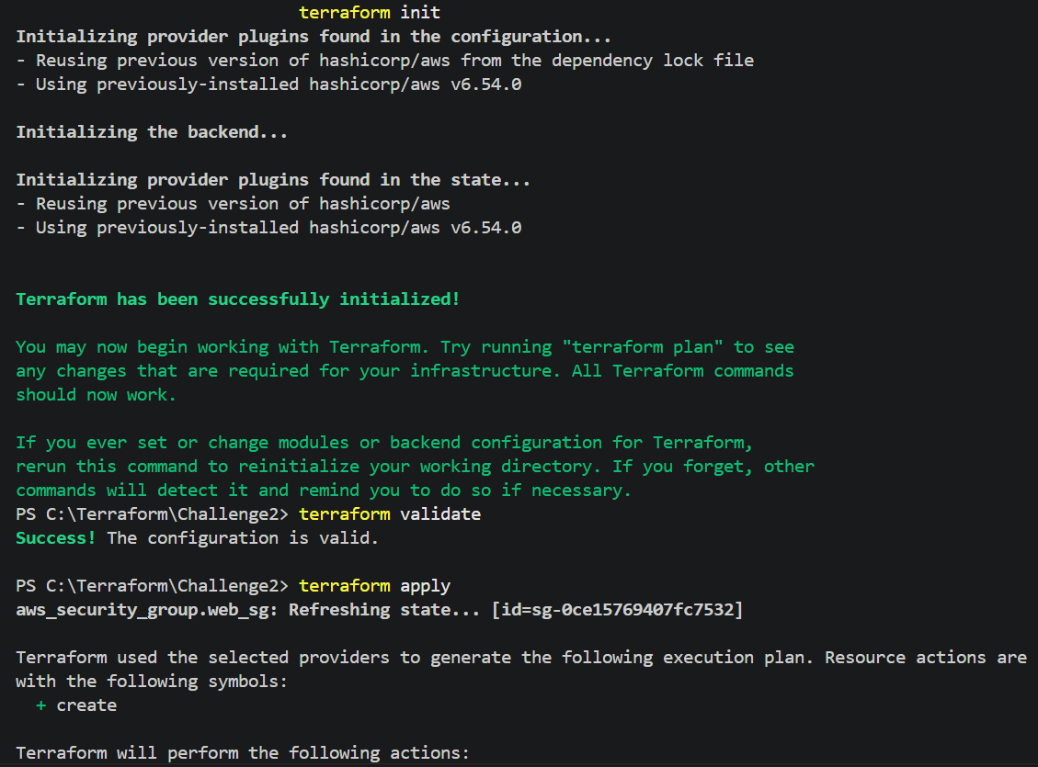
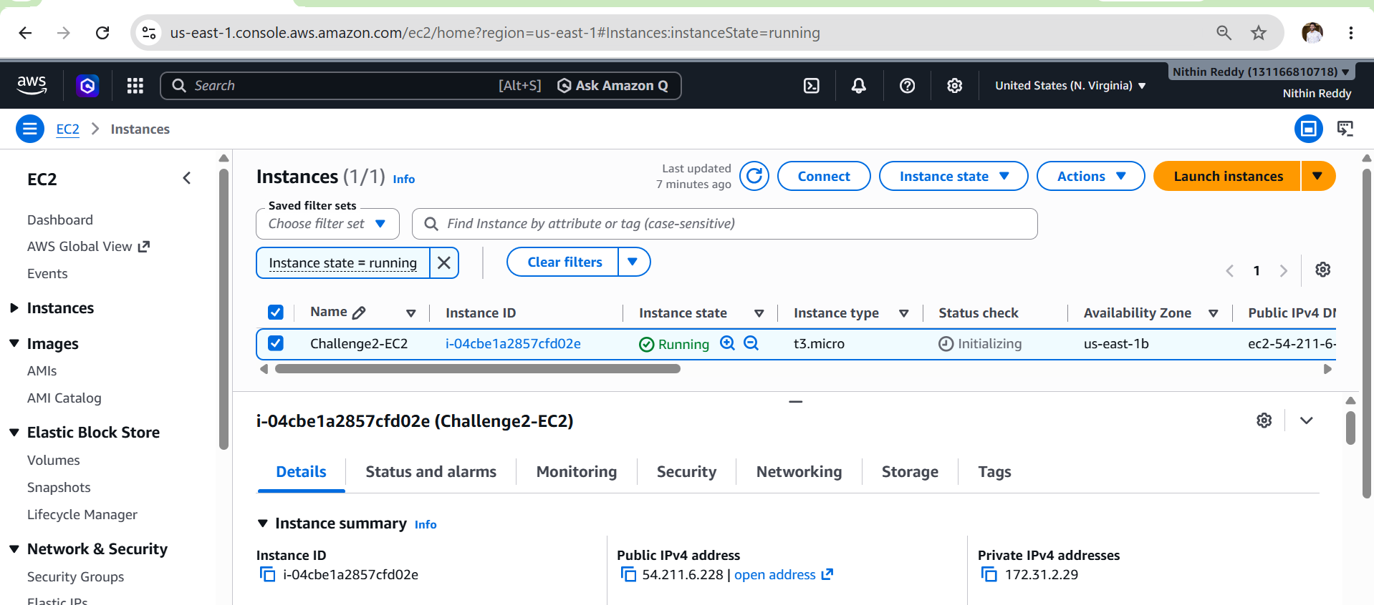
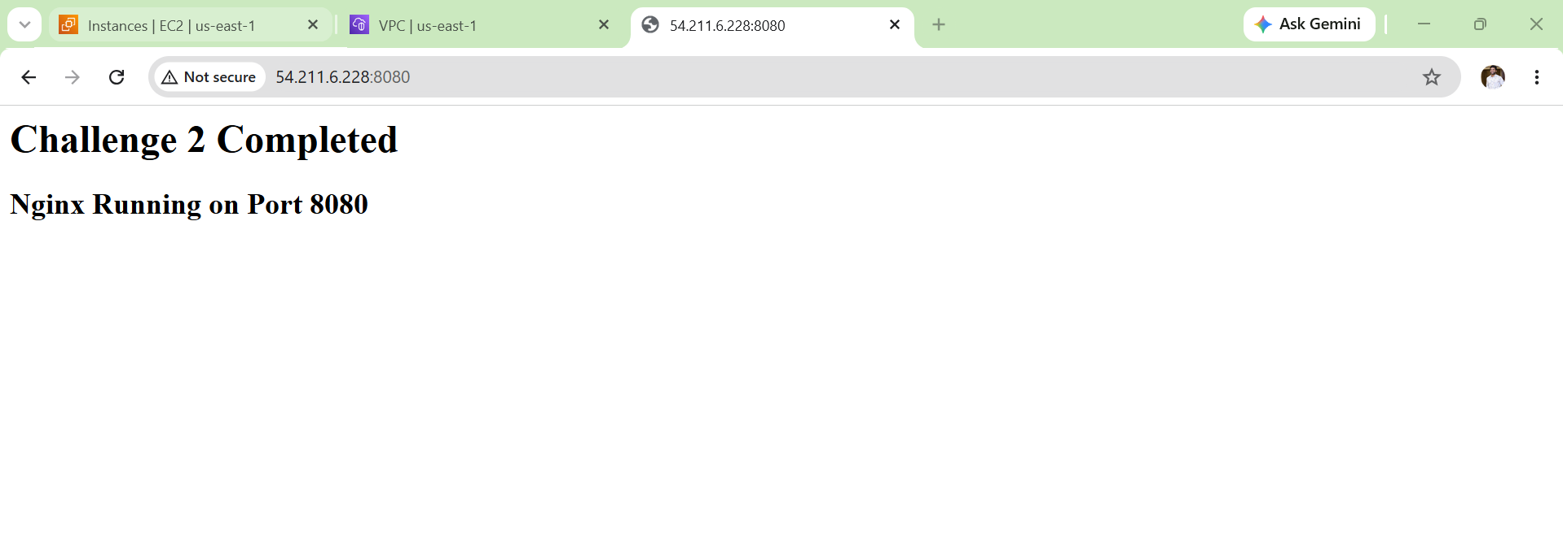

Validation
- Verified Terraform configuration using terraform validate.
- Generated the execution plan successfully using terraform plan.
- Provisioned the EC2 instance using terraform apply.
- Confirmed the EC2 instance is in the Running state in the AWS EC2 Console.
- Verified that Nginx (web server) was installed successfully on the EC2 instance.
Outcome
- Successfully installed and configured the Nginx web server on the EC2 instance.
- Configured the web server to listen on port 8080.
- Automated the installation and configuration using Terraform user_data.
- Verified that the web server starts automatically after the instance boots.
- Successfully accessed the web application through the EC2 Public IP on port 8080.
- Completed the challenge with Infrastructure as Code (IaC) using Terraform.
Challenge 3
Create a Docker Compose file for the project:
https://github.com/betawins/cricbuzz-docker-hello-world.git

Expose the application on Port 8000.

Objective
The objective of this challenge is to deploy the Cricbuzz Hello World application using Docker Compose. The application should run inside a Docker container and be accessible through port 8000. This prepares the environment for Challenge 4, where the Nginx web server will forward requests to this Docker service.

Prerequisites
- Challenge 1 completed.
- Challenge 2 completed.
- Ubuntu EC2 instance running.
- Docker installed.
- Docker Compose installed.
- Security Group allows:
  - SSH (22)
  - HTTP (8080)
  - Docker Application (8000)

Architecture
Internet
│
▼
EC2 Instance
│
┌─────────────┐
│ Docker │
│ Compose │
└─────────────┘
│
▼
Cricbuzz Hello World Container
│
▼
Port 8000
Implementation Steps
- Launch the EC2 instance created in Challenge 2.
- Connect to the EC2 instance using SSH.
- Update the Ubuntu packages.
- Install Git on the EC2 instance.
- Install Docker Engine.
- Start and enable the Docker service.
- Add the ubuntu user to the Docker group.
- Log out and log back in to apply Docker group permissions.
- Verify the Docker installation.
- Install Docker Compose.
- Verify the Docker Compose installation.
- Clone the GitHub repository:
https://github.com/betawins/cricbuzz-docker-hello-world.git
- Navigate to the project directory.
- Build the Go application binary (hello_world).
- Replace the existing Dockerfile with a multi-stage Dockerfile to build and package the application correctly.
- Create a docker-compose.yml file.
- Configure Docker Compose to:
  - Build the image.
  - Create the container.
  - Set PORT=8000.
  - Map port 8000:8000.
  - Restart the container automatically.
- Remove the old lowercase dockerfile (if present).
- Stop and remove any previously created containers.
- Rebuild the Docker image using:
docker-compose build --no-cache
- Start the container in detached mode using:
docker-compose up -d
- Verify the container status using:
docker ps
- Verify that the application is listening on port 8000.
- Access the application using:
http://<EC2-Public-IP>:8000
- Confirm that the application loads successfully in the browser.

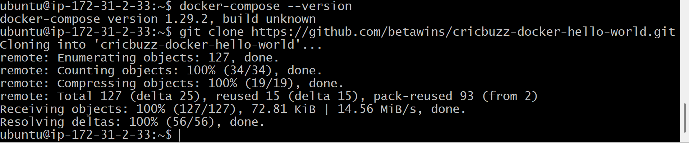
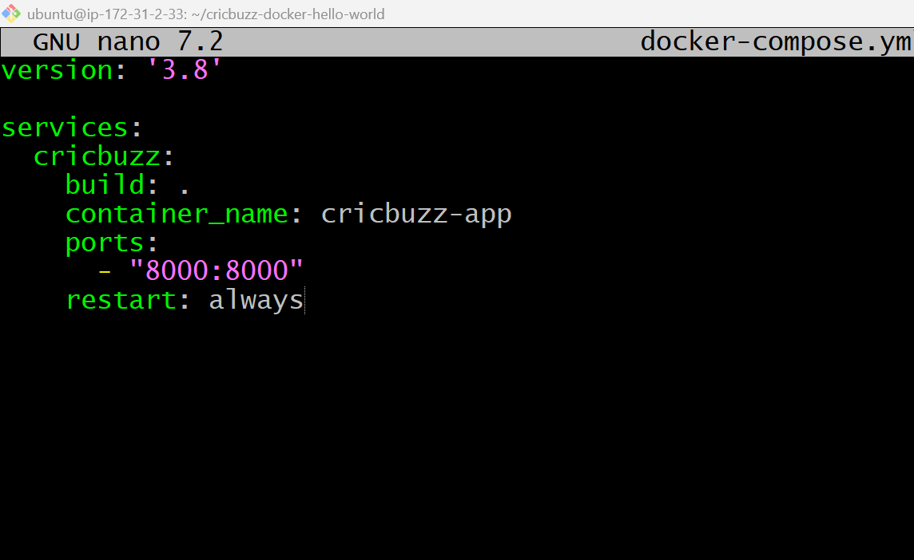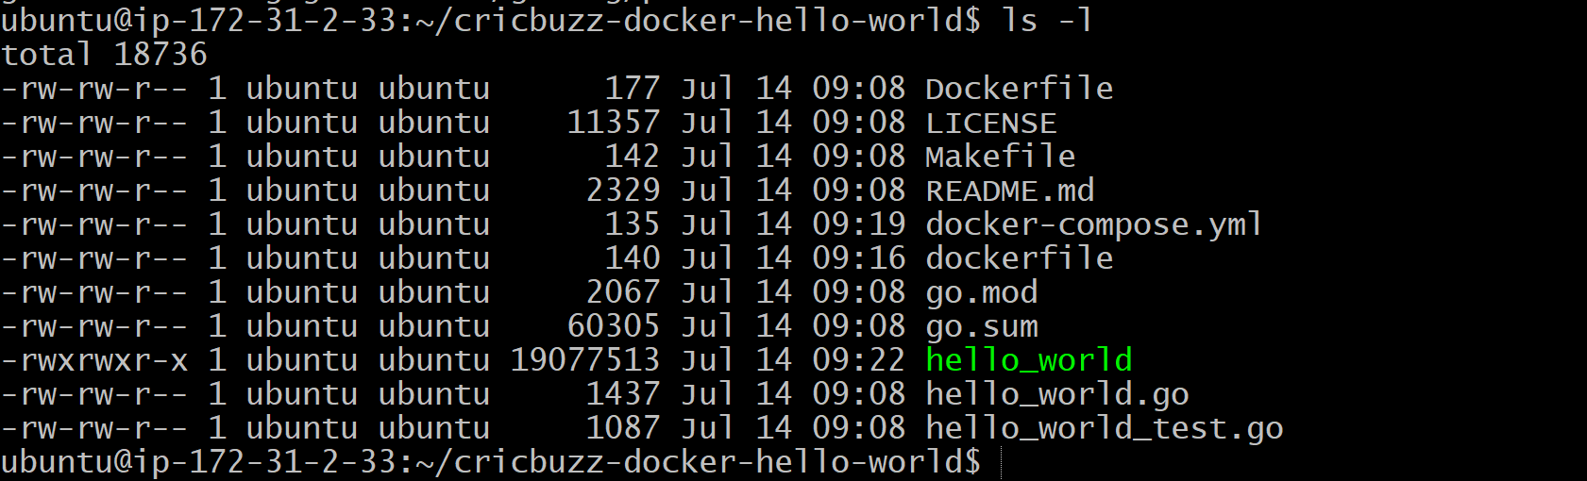
After docker compose build & docker-compose up -d
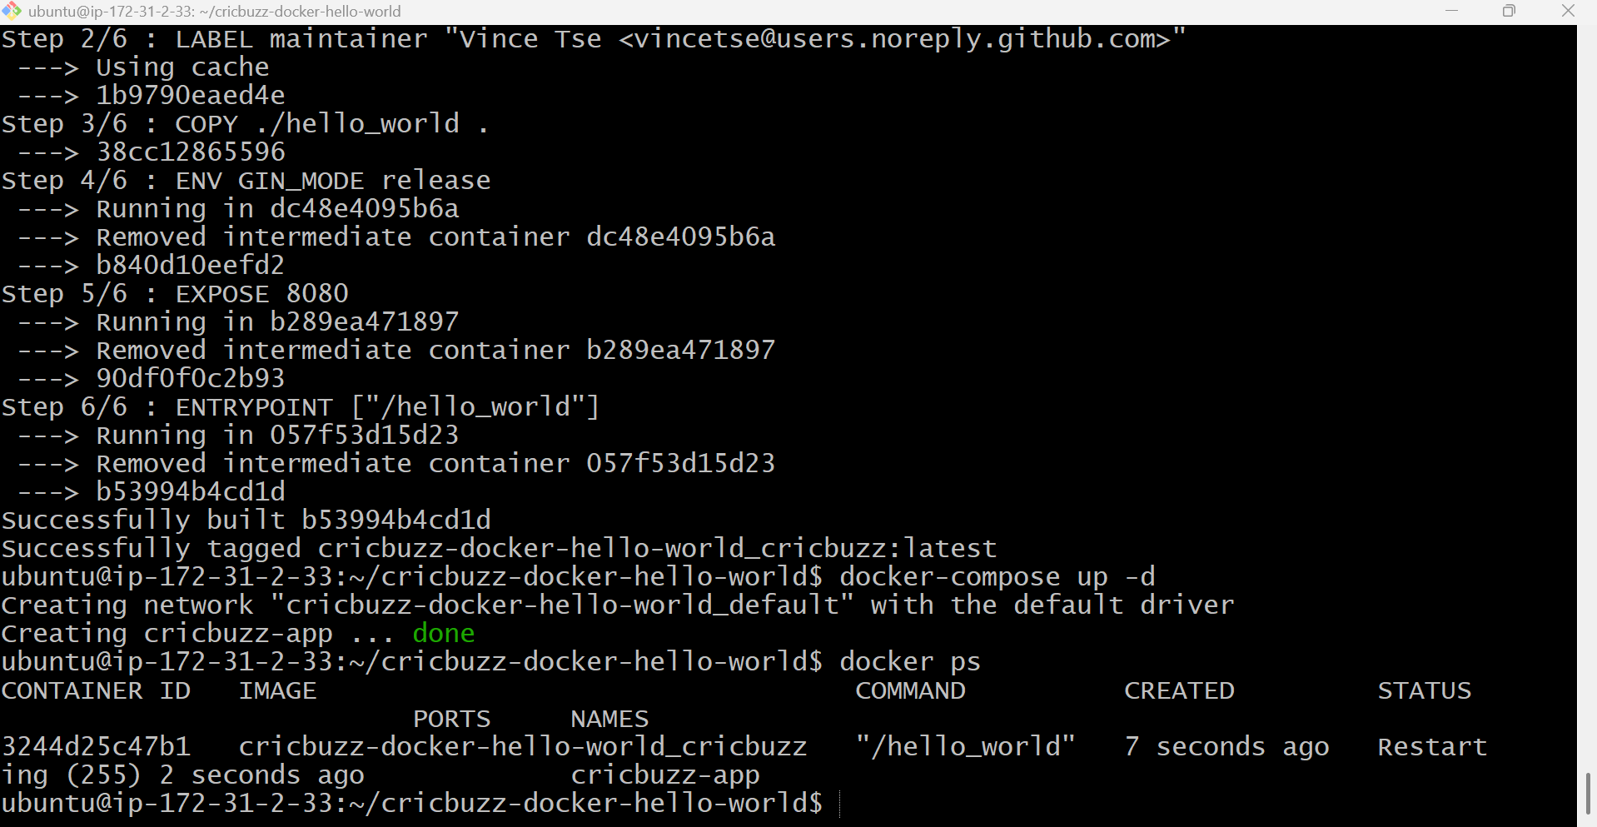
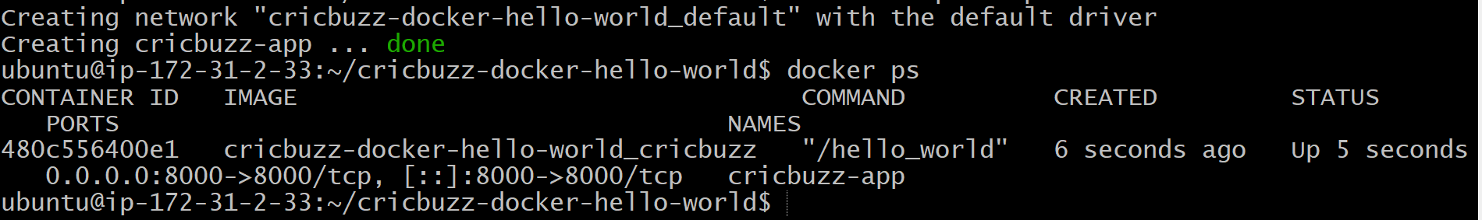
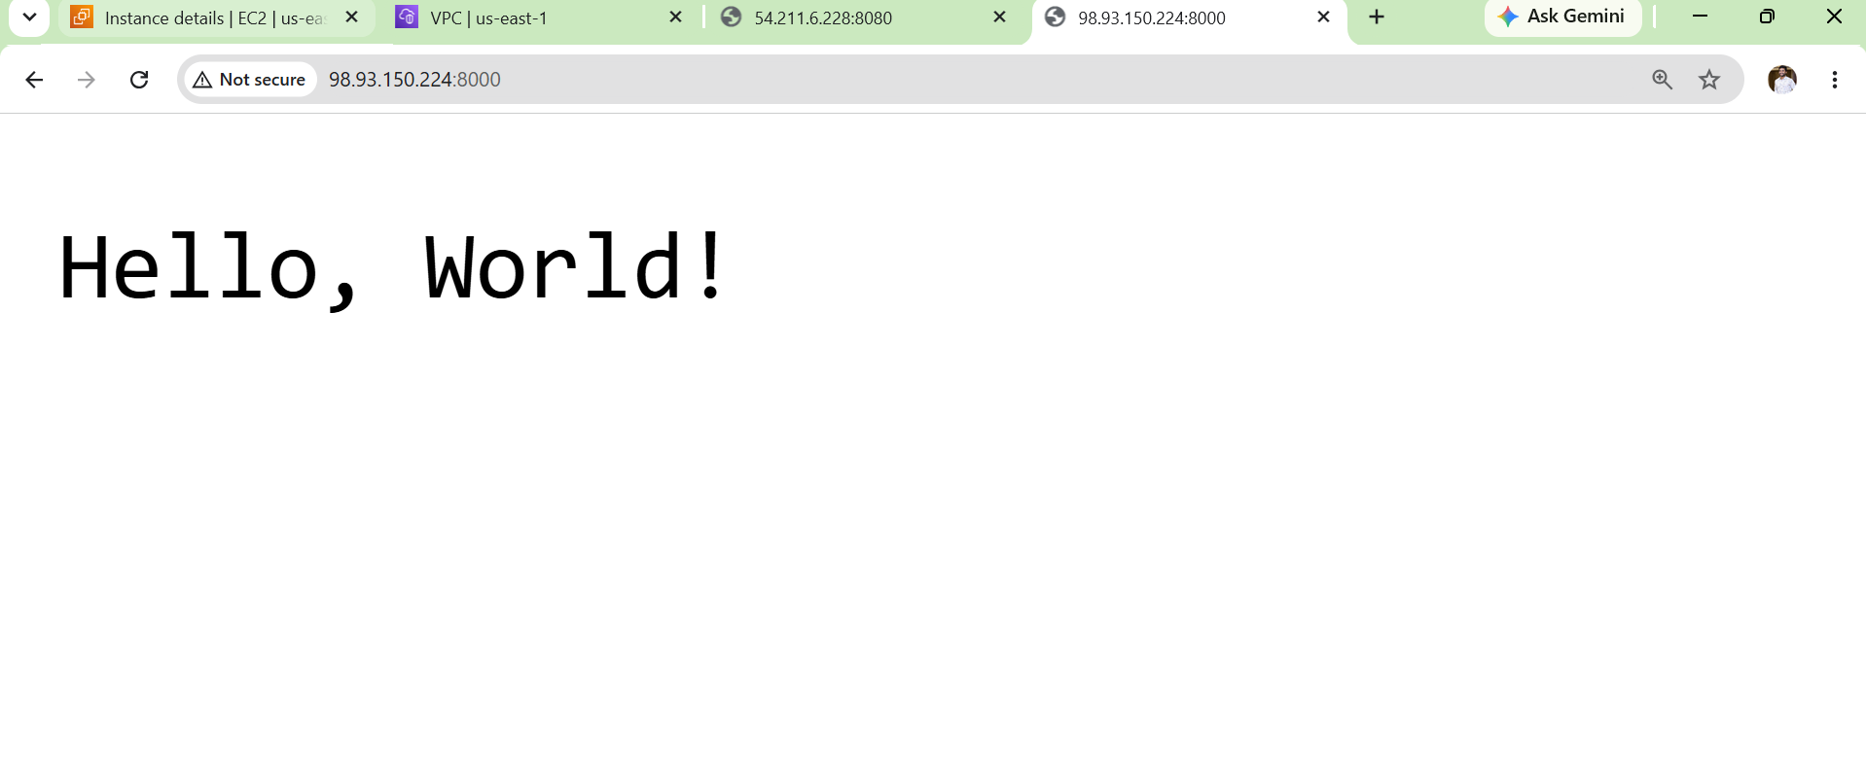
Validation
- Verified Docker is installed successfully.
- Verified Docker Compose is installed.
- Successfully cloned the GitHub repository.
- Successfully created the docker-compose.yml file.
- Successfully built the Docker image using Docker Compose.
- Successfully started the Docker container.
- Verified the container is running using docker ps.
- Verified the application is listening on port 8000.
- Accessed the application using:
http://<EC2-Public-IP>:8000
- Confirmed the application is reachable and working correctly.

Outcome
- Successfully deployed the Cricbuzz Hello World application using Docker Compose.
- Created a reusable docker-compose.yml configuration.
- Exposed the application on port 8000.
- Verified the application is running inside a Docker container.
- Prepared the environment for Challenge 4, where the Nginx web server on port 8080 will act as a reverse proxy and forward requests to the Docker application running on port 8000.

Challenge 4 : Make the web server point to the above service so that 8080 returns the response from the Docker service
Objective
Configure the Nginx web server to act as a Reverse Proxy, so that:
- User accesses http://EC2-Public-IP:8080
- Nginx receives the request
- Nginx forwards it to the Docker application on port 8000
- Docker application sends the response back through Nginx

Architecture
User Browser
│
▼
http://EC2-Public-IP:8080
│
▼
Nginx (Reverse Proxy)
│
▼
localhost:8000
│
▼
Docker Container

Prerequisites
- AWS EC2 instance is running.
- Ubuntu OS is installed.
- Terraform Challenge 1 & 2 completed.
- Docker Engine installed and running.
- Docker Compose installed.
- Cricbuzz Docker application is built successfully.
- Docker container is running on port 8000.
- Nginx web server is installed.
- Security Group allows inbound traffic on 8080.
- Port 8080 is free (or Jenkins is moved to another port such as 8081).
Implementation Steps
- Launch the EC2 instance.
- Connect to the EC2 instance using SSH.
- Verify that the Docker container is running.
- Verify the application is accessible on localhost:8000.
- Install Nginx (if not already installed).
- Start and enable the Nginx service.
- Open the default Nginx configuration file.
- Configure Nginx to listen on port 8080.
- Configure the Reverse Proxy using proxy_pass http://localhost:8000.
- Save the Nginx configuration.
- Test the Nginx configuration using nginx -t.
- Restart the Nginx service.
- Verify that Nginx is listening on port 8080.
- Open the AWS Security Group.
- Add an inbound rule for TCP Port 8080.
- Access the application using:
http://<EC2-Public-IP>:8080
- Verify that requests received on port 8080 are forwarded to the Docker application running on port 8000.
- Confirm the application loads successfully in the browser.

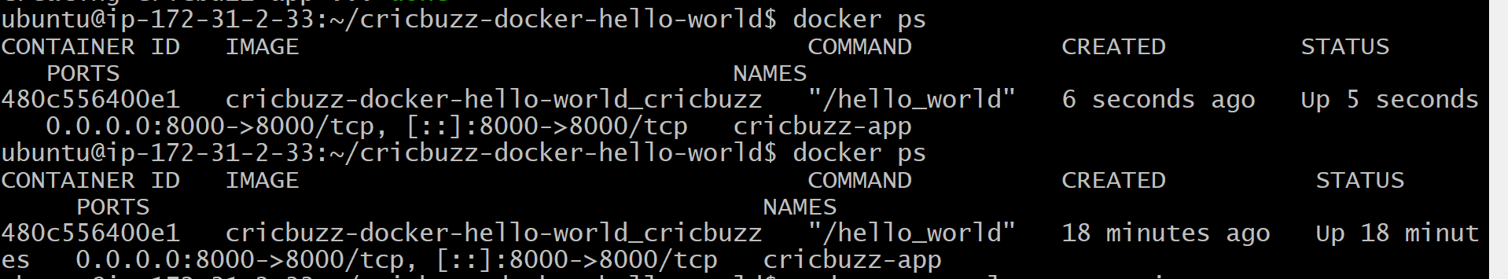
sudo systemctl status nginx
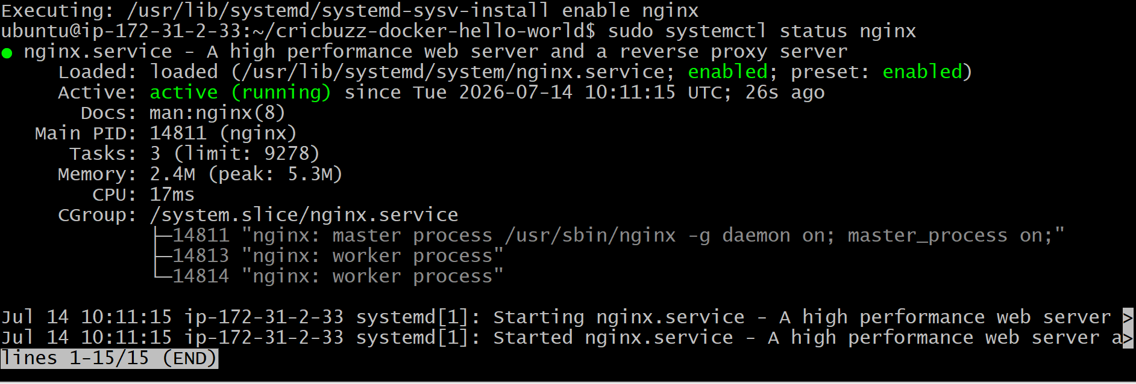
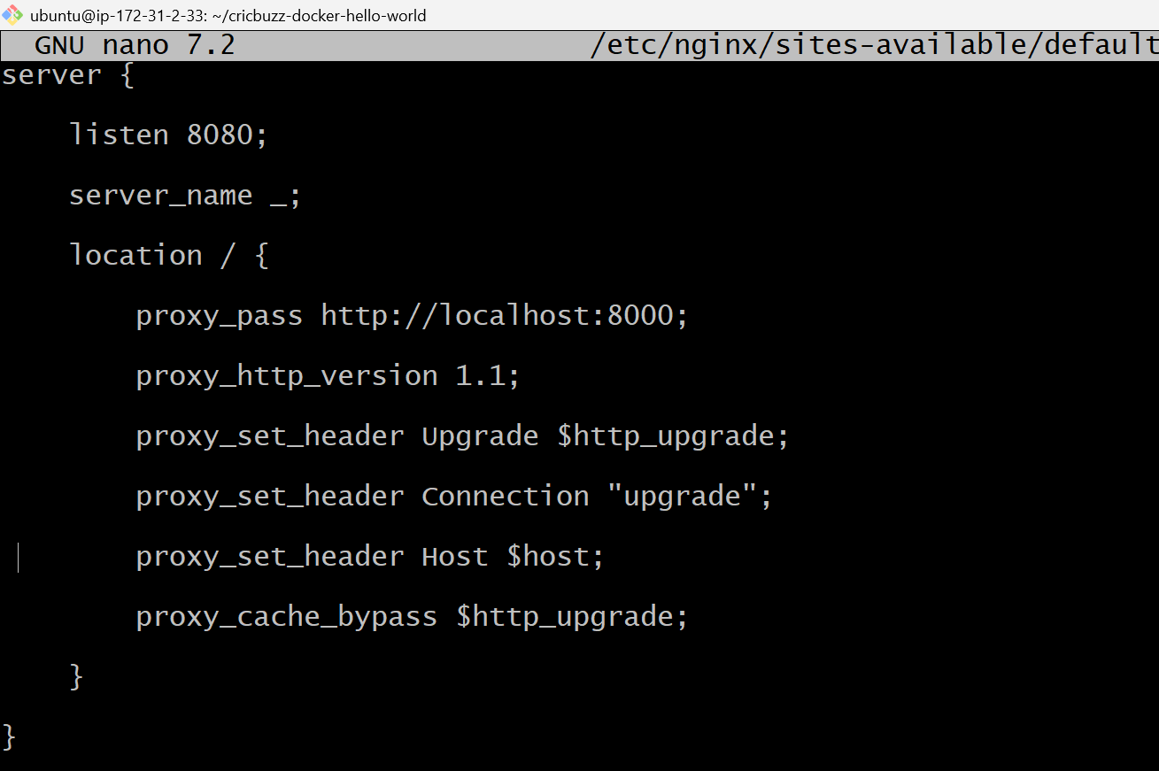
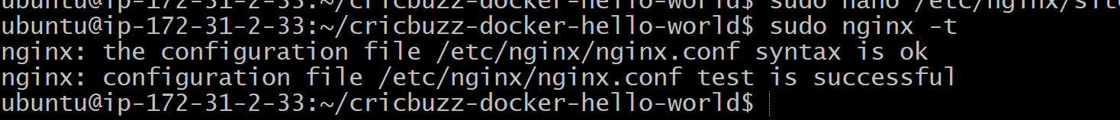
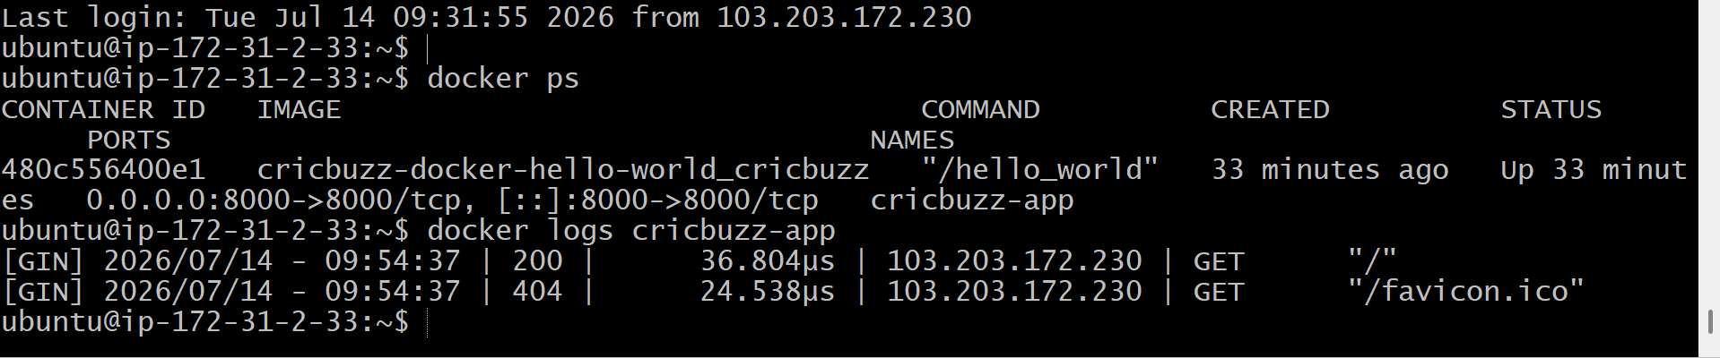
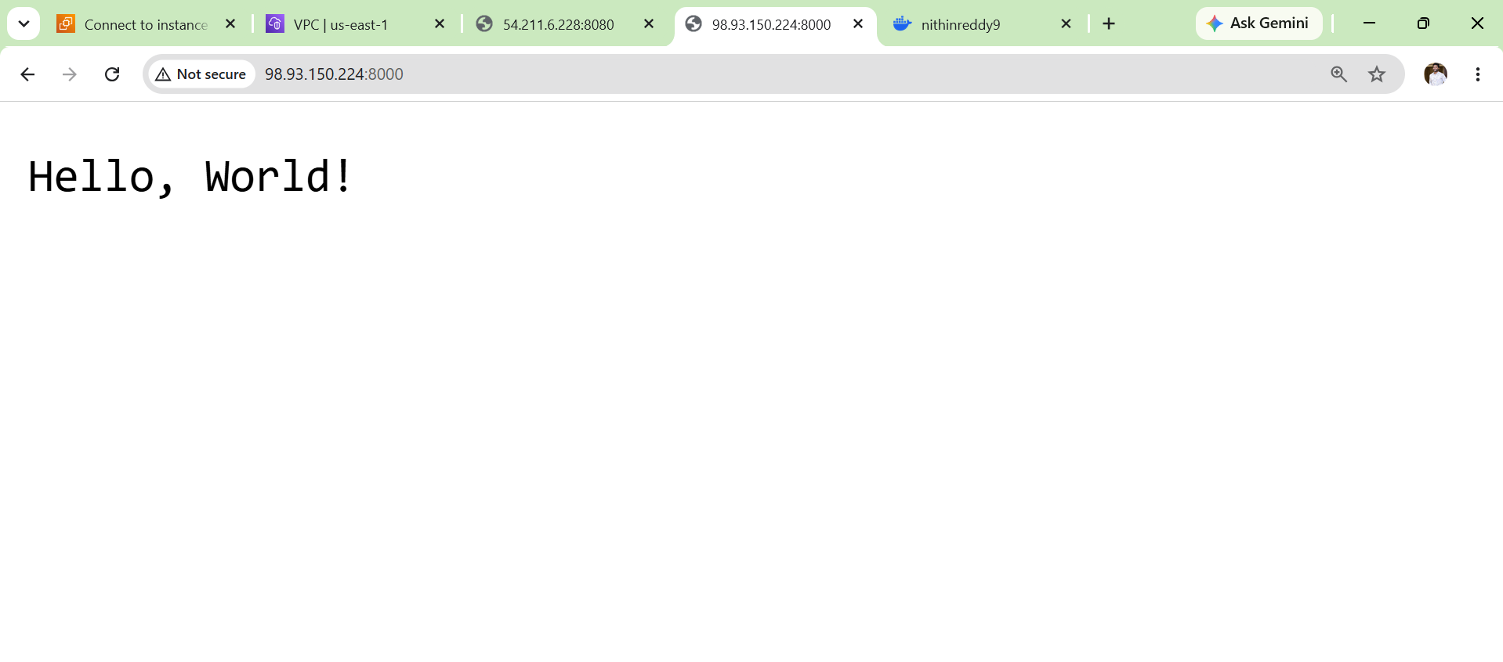

Validation
- Verified Docker container is running successfully.
- Verified the application is accessible on port 8000 locally.
- Installed and configured Nginx as a reverse proxy.
- Verified the Nginx configuration using sudo nginx -t.
- Restarted the Nginx service successfully.
- Verified Nginx is listening on port 8080.
- Confirmed that requests to http://EC2-Public-IP:8080 are forwarded to the Docker application on port 8000.
- Verified the application loads correctly through the reverse proxy.

Outcome
- Successfully configured Nginx as a reverse proxy.
- Redirected all HTTP requests from port 8080 to the Docker application on port 8000.
- Verified end-to-end communication between the browser, Nginx, and the Docker container.
- Prepared the environment for Challenge 5, where application logs will be written to /var/log/cb.log.

Challenge 5: Configure the Application to Save Logs in /var/log/cb.log
Objective
Configure the Cricbuzz application so that all application logs are written to the file:
/var/log/cb.log
Prerequisites
- Challenge 1 completed (EC2 created)
- Challenge 2 completed (Web Server installed)
- Challenge 3 completed (Docker Compose running)
- Challenge 4 completed (Nginx Reverse Proxy configured)
- Docker service running
- Cricbuzz container running
- Ubuntu EC2 instance accessible via SSH
Implementation Steps
- Connect to the EC2 instance using SSH.
- Verify that the Docker container is running using docker ps.
- Create the log directory (if it does not exist).
- Create the log file /var/log/cb.log.
- Assign the required permissions to the log file.
- Navigate to the project directory (cricbuzz-docker-hello-world).
- Edit the docker-compose.yml file.
- Configure the application/container to use /var/log/cb.log for logging.
- Save the Docker Compose configuration.
- Stop the existing Docker container using docker-compose down.
- Rebuild the Docker image using docker-compose build --no-cache.
- Start the container using docker-compose up -d.
- Verify the container is running successfully.
- Access the application multiple times using curl localhost:8000 or a web browser to generate log activity.
- Verify that the log file exists at /var/log/cb.log.
- Check the log file contents using cat /var/log/cb.log or monitor it using tail -f /var/log/cb.log.

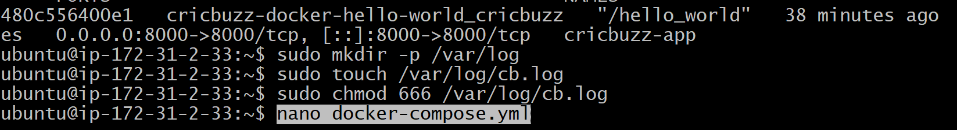
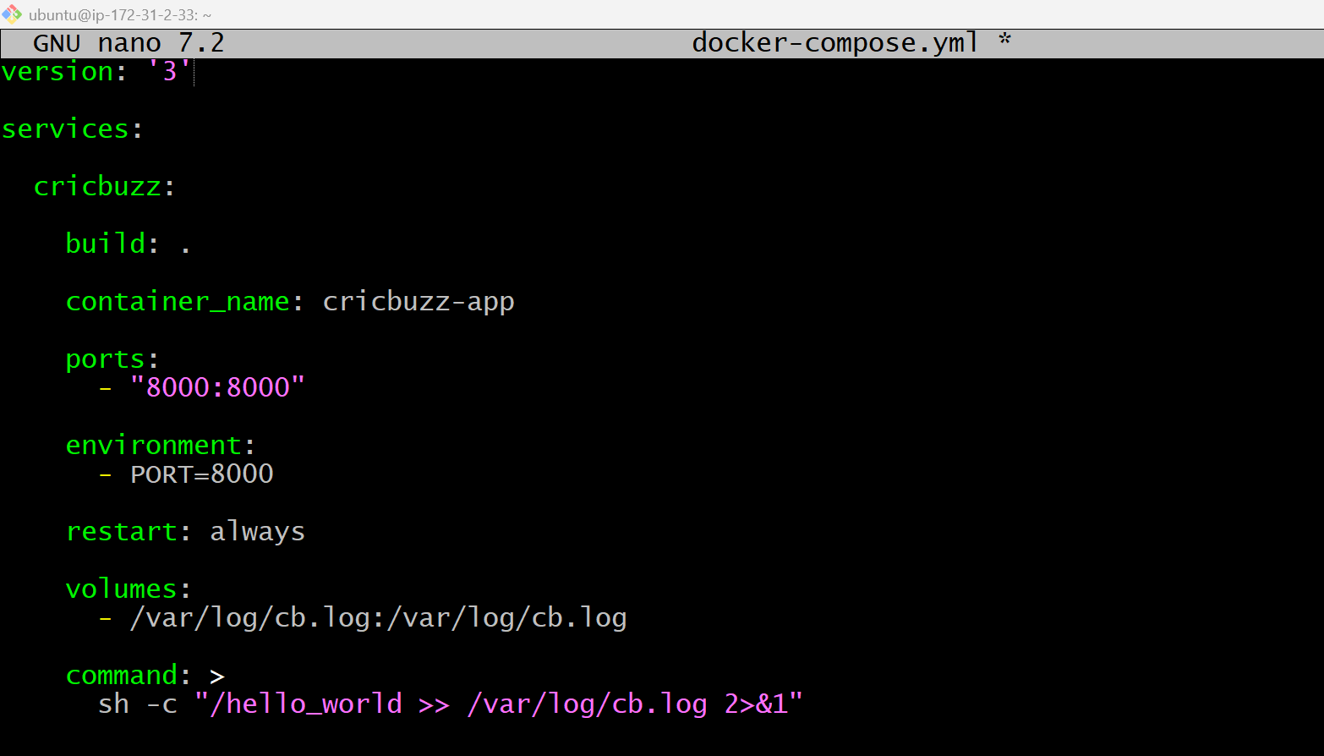
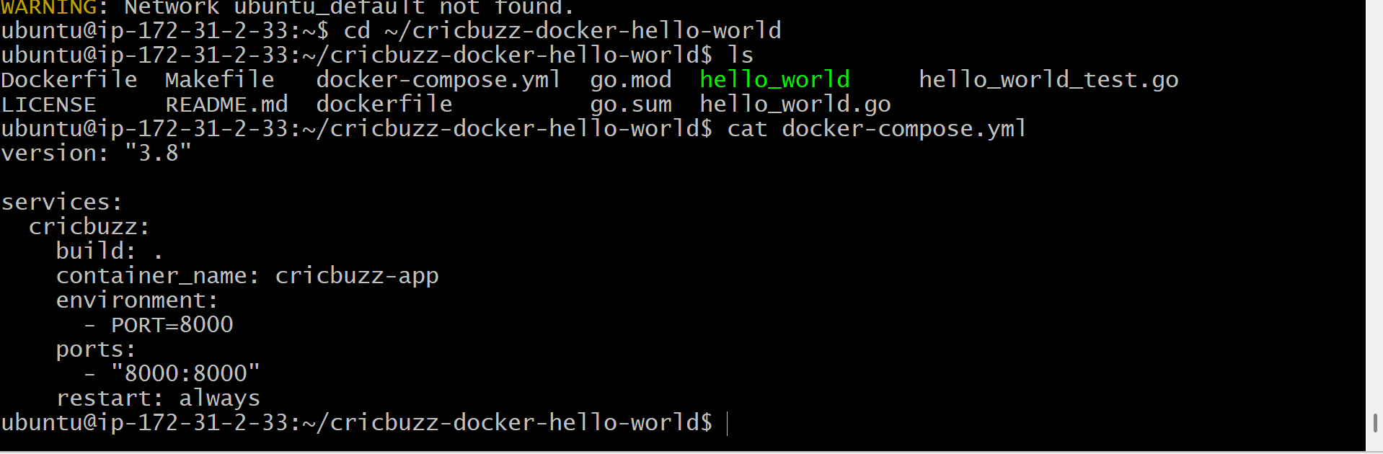
docker-compose build --no-cache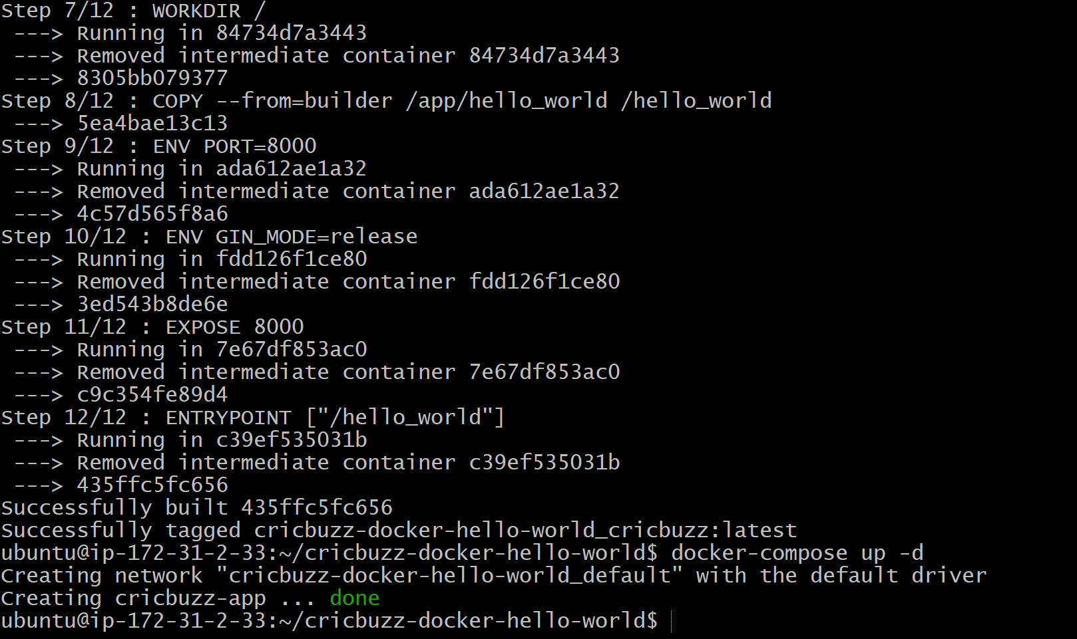
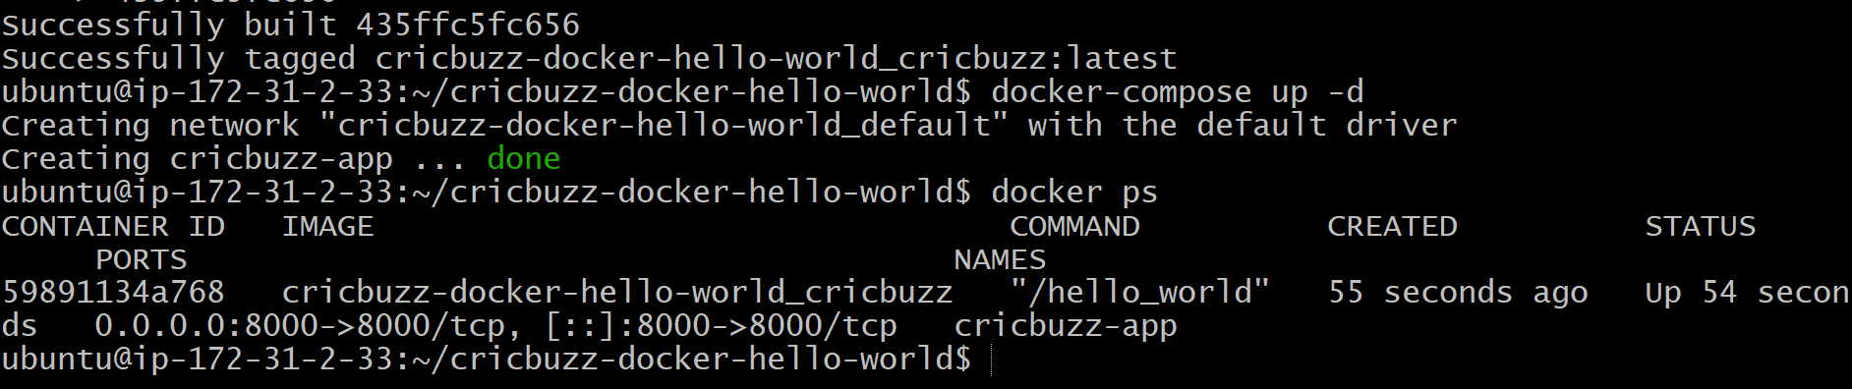
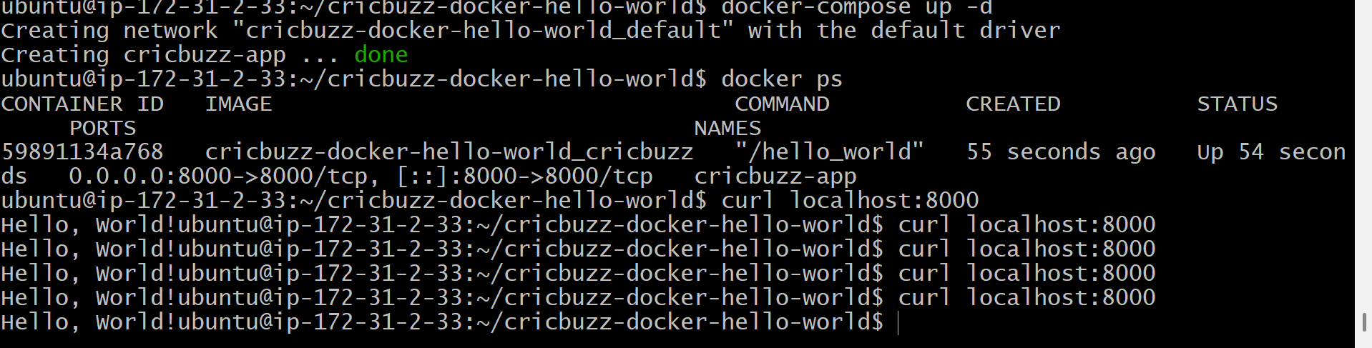
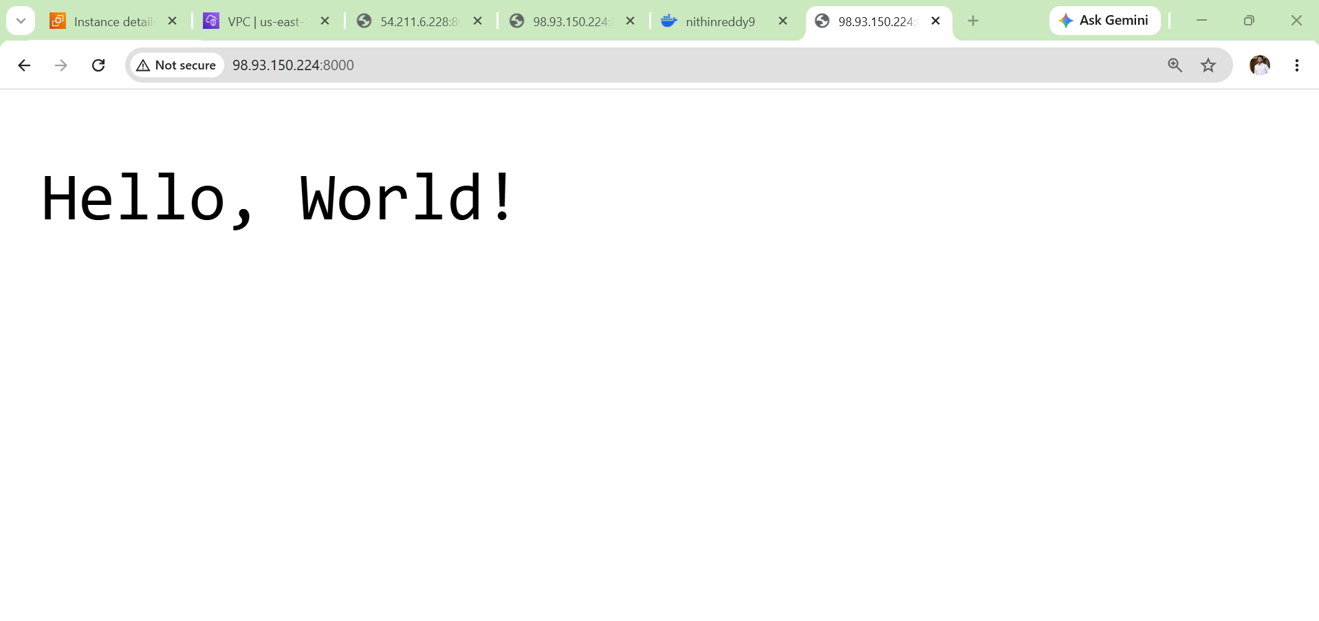
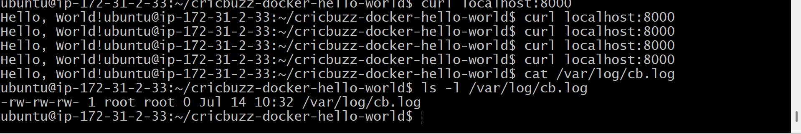
Validation Points
- Verified Docker container is running.
- Created the /var/log/cb.log log file.
- Configured the application/container to write logs to /var/log/cb.log.
- Verified log generation after accessing the application.
- Confirmed logs are stored in the specified file.
- Verified log file permissions and accessibility.
Outcome
- Successfully configured application logging to /var/log/cb.log.
- Verified that application requests and startup logs are written to the log file.
- Enabled centralized log storage for easier monitoring and troubleshooting.

Challenge 6: Configure Log Rotation for /var/log/cb.log
Objective
Configure logrotate to automatically rotate the application log file (/var/log/cb.log) when it grows, keeping old logs compressed and preventing the log file from consuming excessive disk space.
Prerequisites
- Challenge 1 completed (EC2 provisioned).
- Challenge 2 completed (Web server installed).
- Challenge 3 completed (Docker Compose application running).
- Challenge 4 completed (Reverse proxy configured).
- Challenge 5 completed (/var/log/cb.log created).
- Ubuntu EC2 instance accessible.
- Docker container running.
- cb.log file exists.
Challenge 6 Steps implemented
- Connected to the EC2 instance.
- Verified the existence of /var/log/cb.log.
- Verified that logrotate is installed.
- Created a custom logrotate configuration file at /etc/logrotate.d/cb.
- Configured daily log rotation with compression and retention of 7 log files.
- Enabled missingok, notifempty, and copytruncate options.
- Verified the configuration file.
- Added sample log entries to /var/log/cb.log.
- Tested the logrotate configuration.
- Verified the log file and rotation configuration.

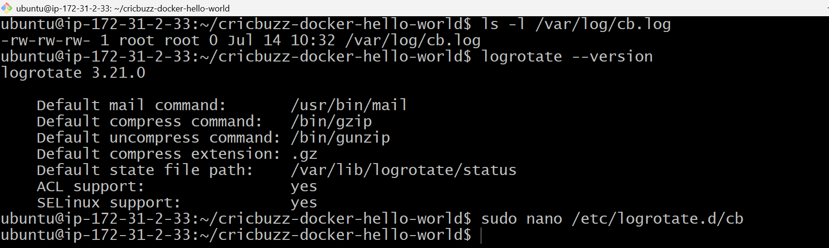

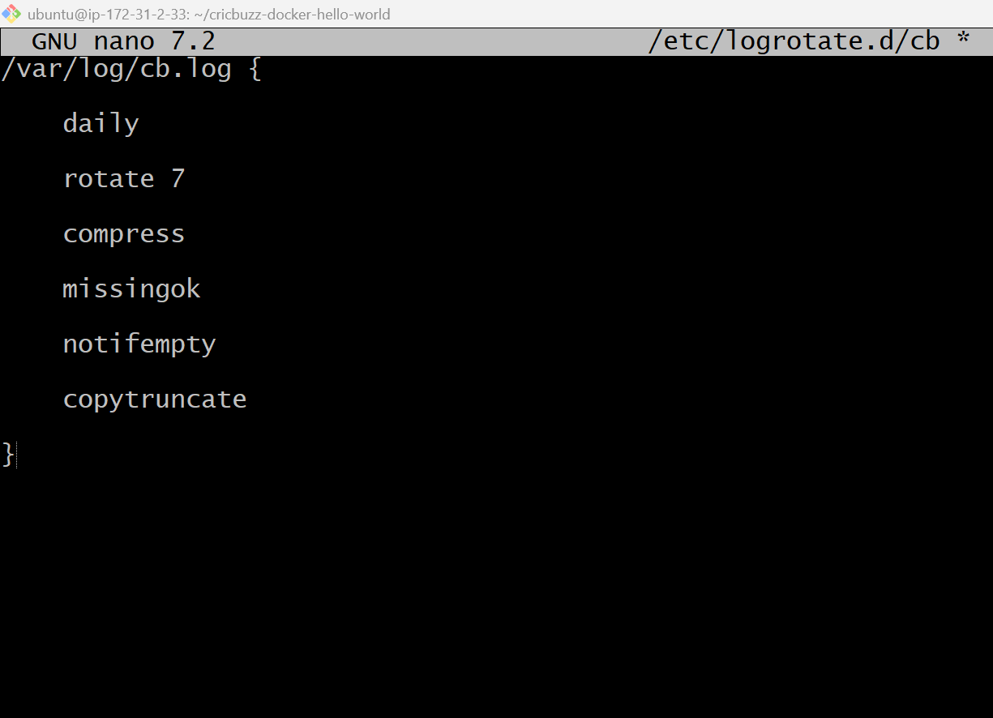
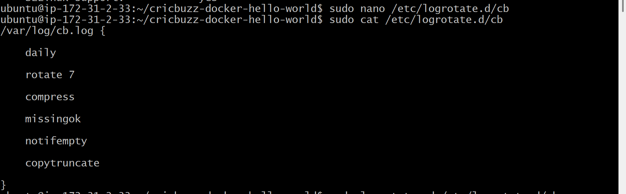
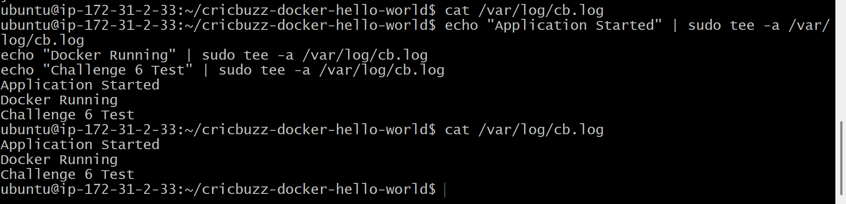
Validation
- Verified logrotate installation.
- Verified /var/log/cb.log exists.
- Verified the custom logrotate configuration.
- Verified sample log entries were written to cb.log.
- Verified the log rotation configuration is ready for automatic execution.
Outcome
- Successfully configured log rotation for the application log file.
- Configured daily rotation with compression and retention of 7 log files.
- Prepared the system for automatic log management, preventing uncontrolled log file growth.

